download the qi library(windows)

Sarah Fraihat

First off, having the python 2.7 is a must in order to install this library, so you might either want to install this on a different user system if you don’t want to give up your current python version.

To install the python 2.7 you might want to go to the python.org website>> downloads>> windows, you’ll find it there.

After you’re done setting up your python, you might want to make sure that it’s in your path, you do that by opening the command prompt and you can do that by writing cmd in your search bar.

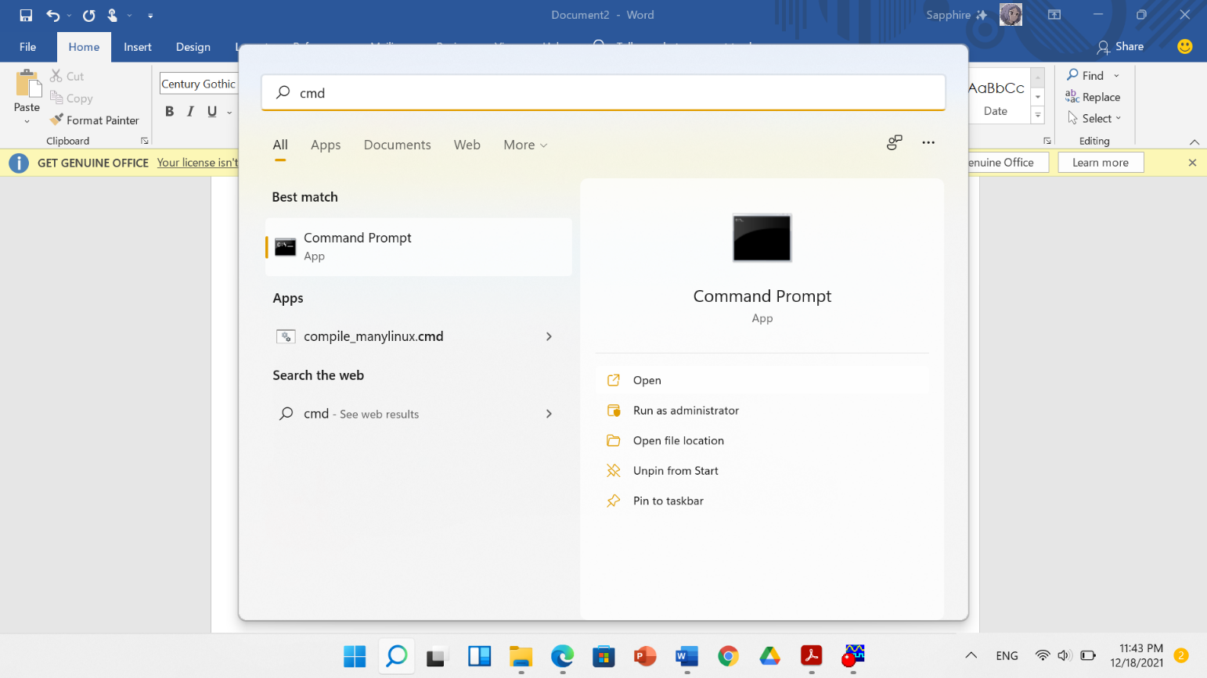

After that you’re going to type python in the cmd, if it successfully gave you the python2.7 as so, you’re good to go.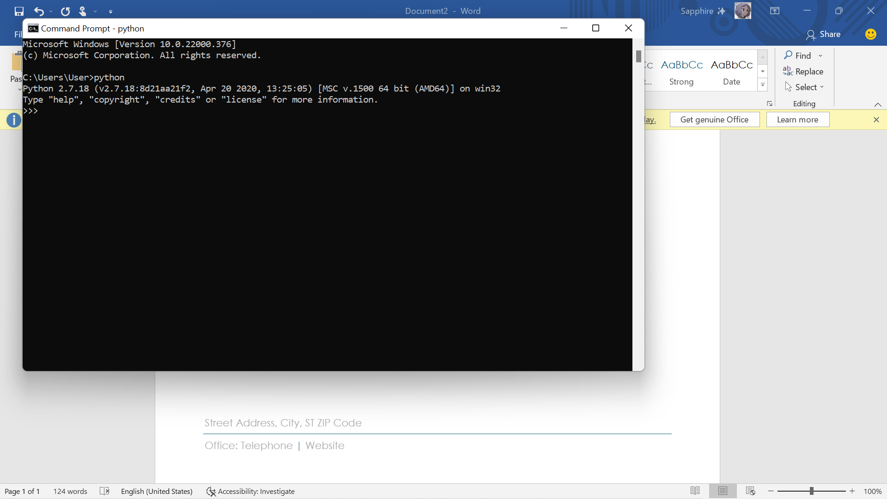

If you didn’t get this exact line for some reason, you might want to do the following steps since this means that python2.7 ISN’T in your system path.

1. Search for system variables in your search bar, click on “environment variable”
2. Click on PATH

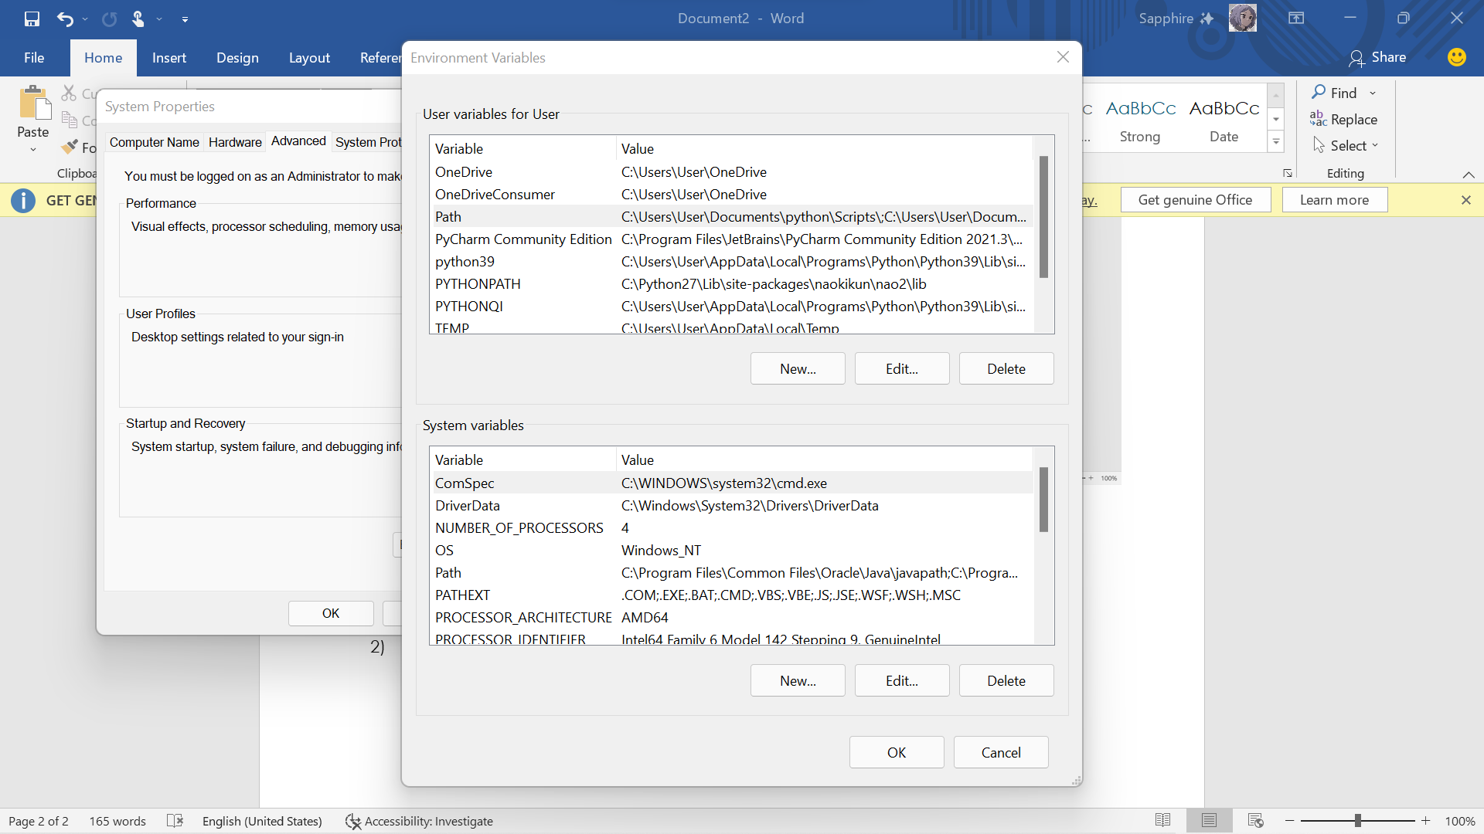

1. After you click on path this will show up, what you want to make sure of is that “C:\python27” and “C:\python27\Scripts” are there, if NOT click on “new” and write them yourself , pay close attention to capitalized letters.

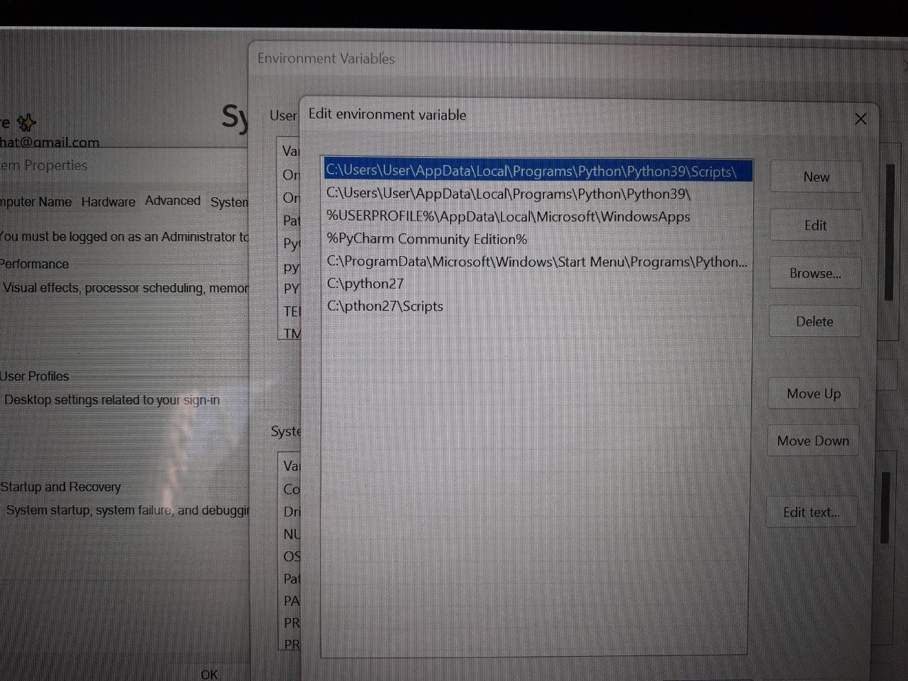

1. After you’ve done that, to make sure that it worked you do the previous step where you go to your cmd and check for the python file.

After you’ve successfully added your python 2.7 to your path, now comes the step where you download the library using the following steps:

1. Visit this website

[NAO⁶ | SoftBank Robotics Developer Center](https://developer.softbankrobotics.com/nao6)

1. After that you might want to click on download and choose your system:

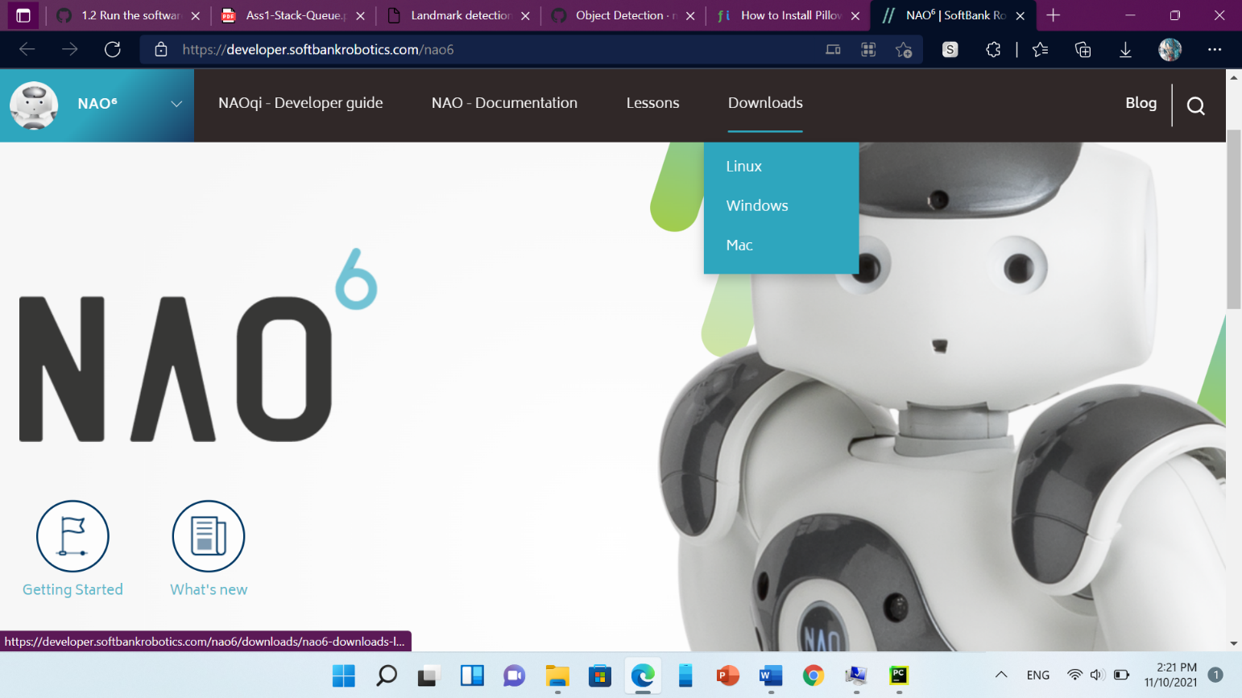

1. click on python SDK to start your download:

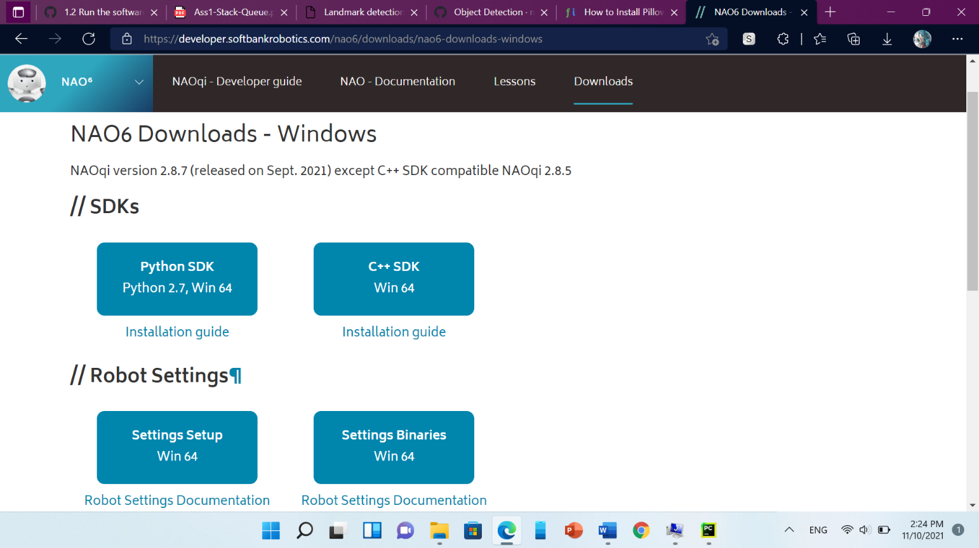

1. After it’s done downloading, rename your zip file so that it eases our work in further steps, then extract your file.

The next step is to go to your local disk and click on python27>lib>site-packages and move your extracted file there ( the extracted file is the qi library that you downloaded) .

After you’ve done that click on your extracted folder while it’s

in the site-packages folder, then click on lib and finally copy that path.

It’ll look like something along the lines of :

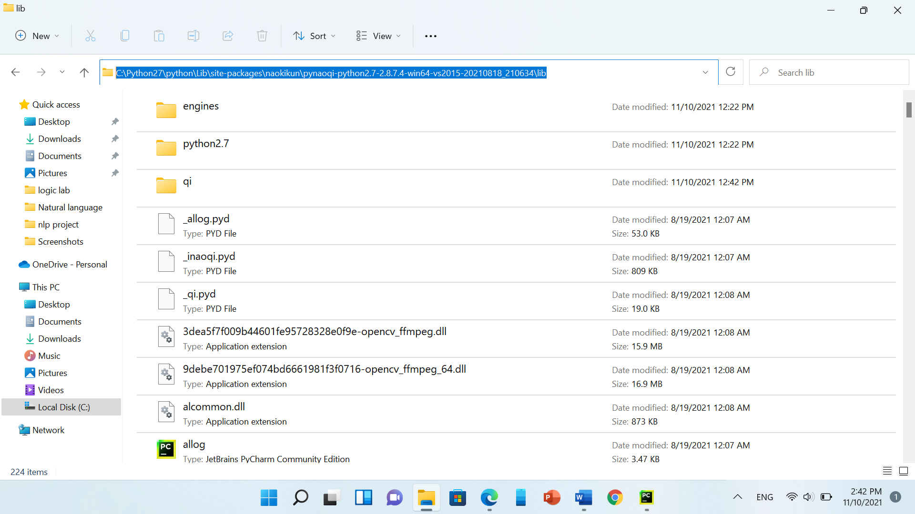

1. Now go back to the system variables, now we don’t need to click on “path” instead click on “new”

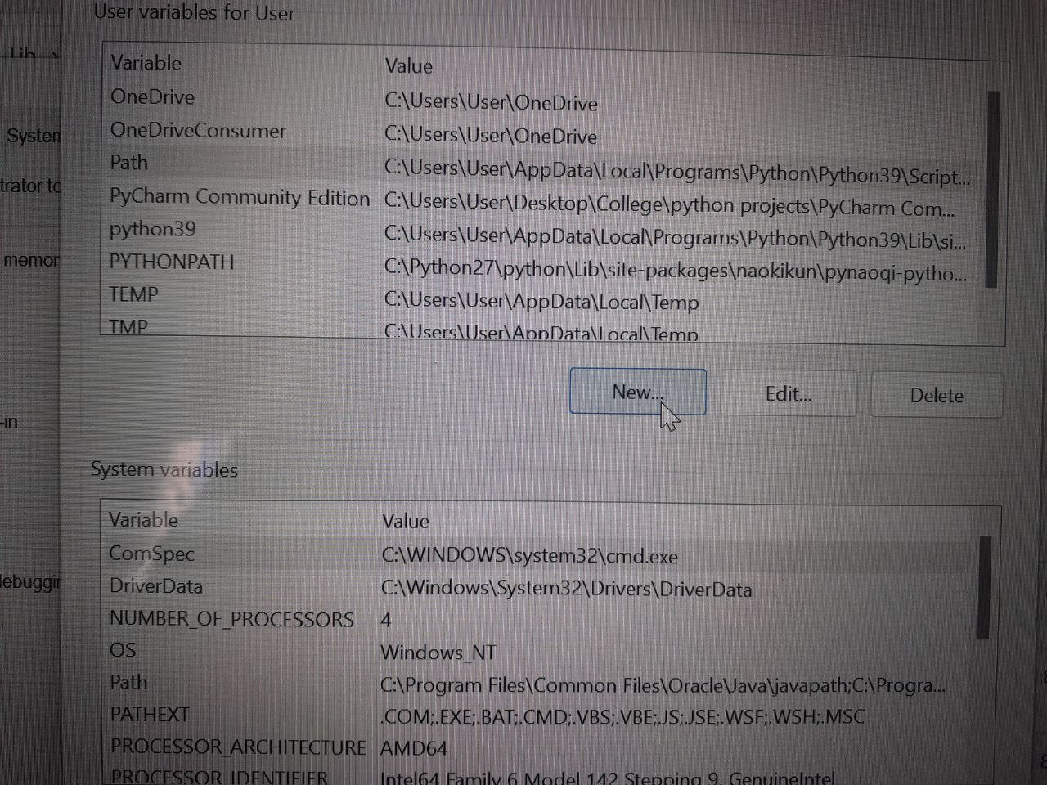

1. Name it “PYTHONPATH” and paste the path you copied from the folder in “path value” then click save and exit.

Finally you have the qi library installed, to make sure of that go to cmd again and type python then import qi, if it doesn’t give you any errors then you’re good to go, if there was an error go back to the steps and make sure that you’ve done them the right way.

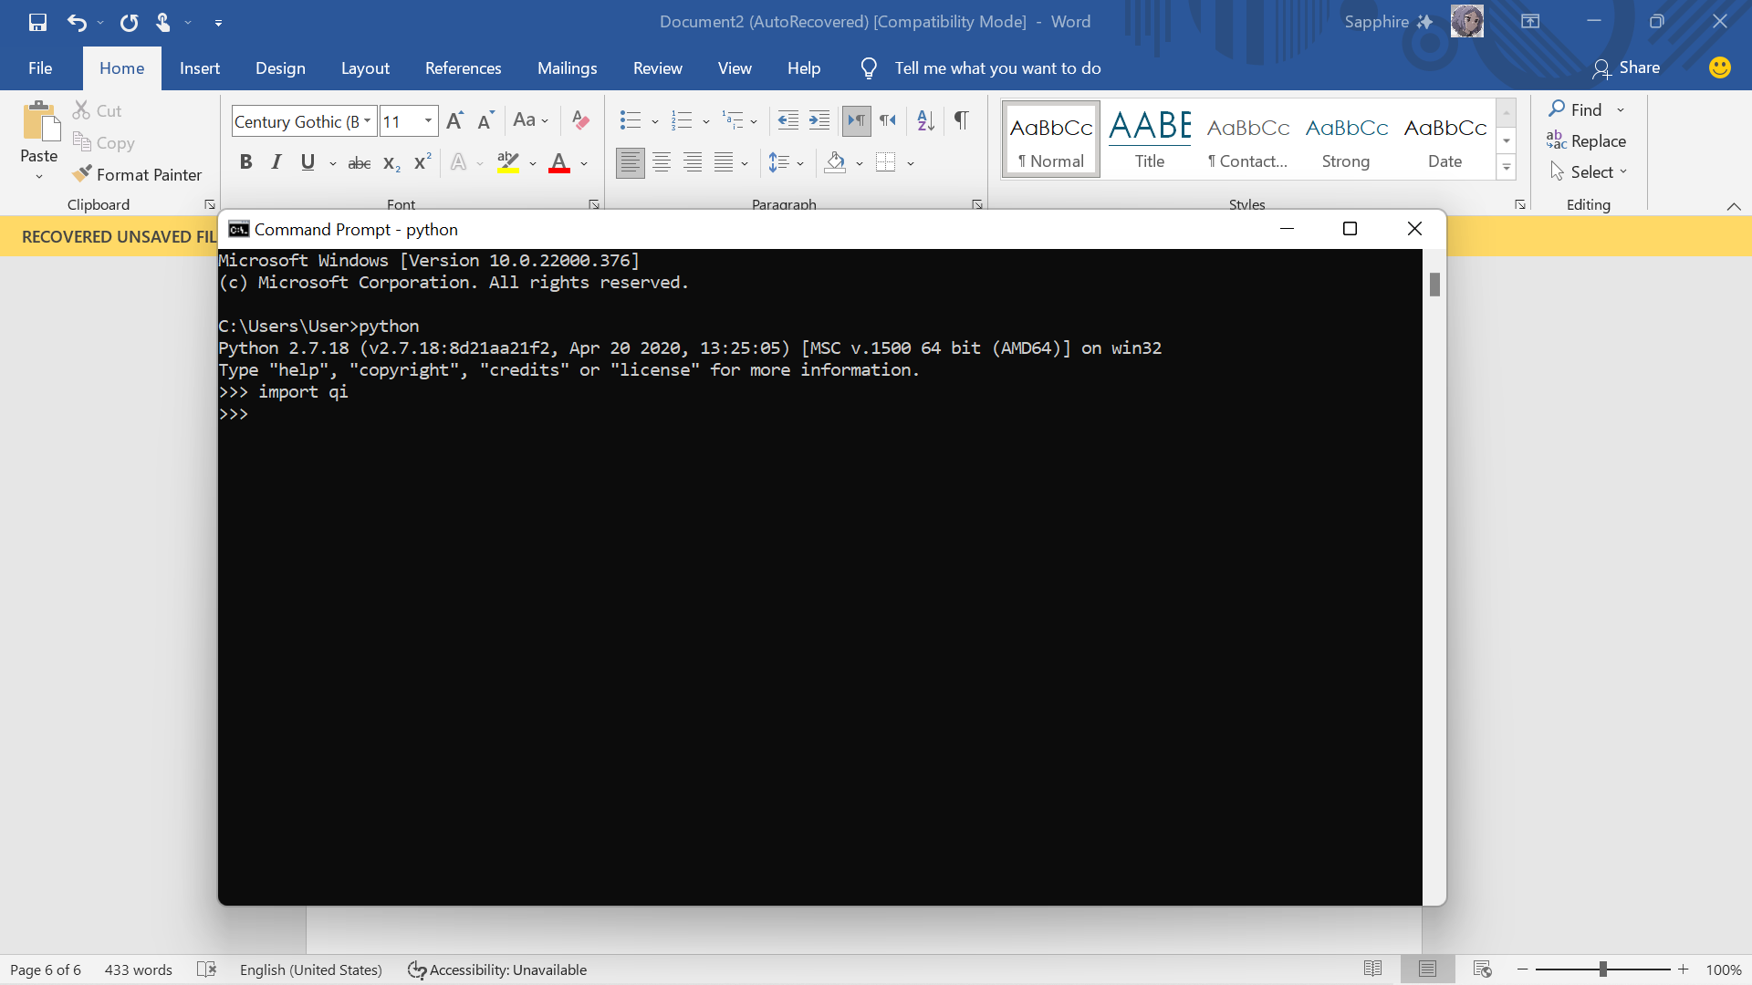

Note: if you have pycharm you have to make python 2.7 your interpreter for you to be able to use this library without errors.